Brief Report on observation of VAW - 2024
28th Oct’24 to 3rd Nov’24

VAW-2024 observed in KLL with the participation of all employees and contract staff. On 28.10.2024, Sh. Sanjay G Gondane, GM (O&M) & OIC have administered the pledge to all employees present on the occasion. Addressing the gathering, Sh. Gondane emphasized that we should frame the scope/ terms and conditions of the tender very carefully so that there will not be any confusion while bidding and complaints from vendors while execution of the jobs. He also highlighted the importance of Pre-Tender Conference (PTC) for successful execution of jobs. The messages received from various dignitaries were read out on the occasion. The Banners and Standy as per the format were displayed at prominent locations of KLL. The various activities scheduled during the week were explained to the employees and requested to participate and also requested to encourage their contract staff to participate in their respective competitions.
As per schedule, an Awareness Gram Sabha for Anjanwel Gram Panchayat was organized on 29.10.2024. The Sarpanch along with all the members of Gram Panchayat were participated in the program. Sh. Yogesh Dhamaskar, Member, Gram Panchayat have spoken on Anti-Corruption at a length. Sh. Sanjay Gondane, GM (O&M) have also spoken about the ill-affects of Corruption and steps to eradicate it. A drawing competition for the students of ZP Adarsh School, Anjanwel was also organized on this year’s theme and prizes were distributed to the winners in the Gram Sabha.
The Essay and Slogan Writing on the theme was conducted for both employees and contract staff separately, wherein all employees and contract staff actively participated. The Drawing/poster making for the wards of employees was also conducted on the given theme.
A quiz programme for sensitizing/creating awareness among the employees was also conducted.
The prize distribution & closing ceremony was held on 04.11.2024, which was attended by Sh. Sanjay G Gondane, General Manager (O&M-Marine/Civil), all HoDs, employees and all the contract staff. Sh. Gondane in his message, appealed to all the employee and staff to be vigilant and time-bound in their respective activities.
Some of the photographs taken during the activities are as under.
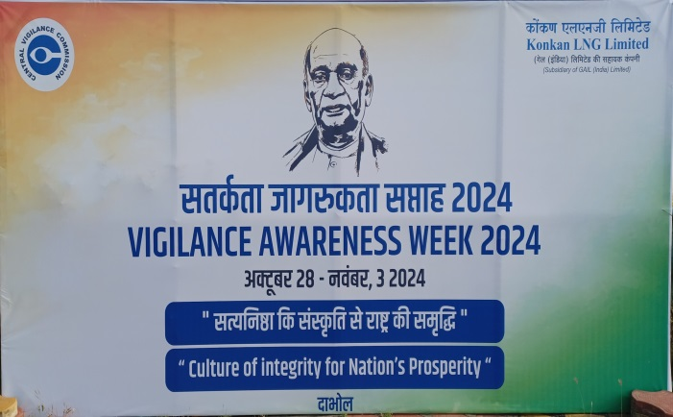 | 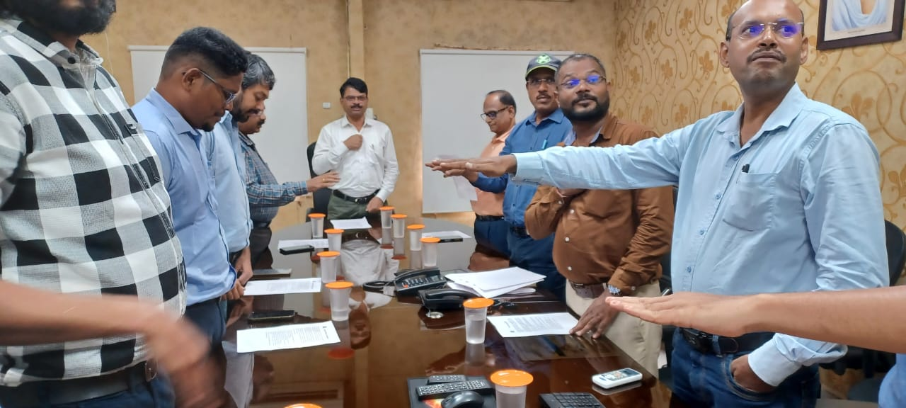
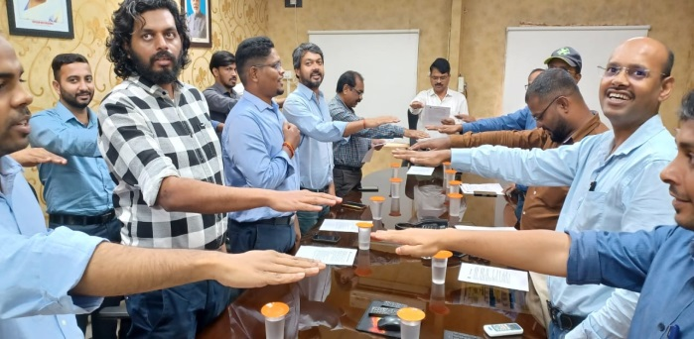 | 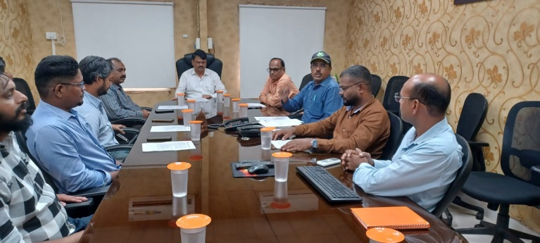
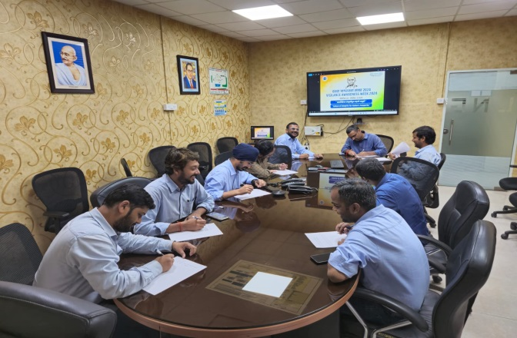 | 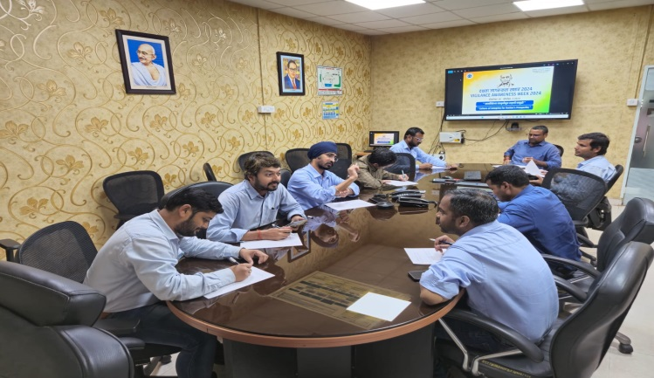
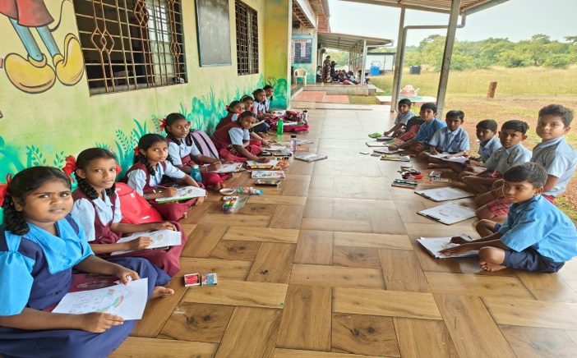 | 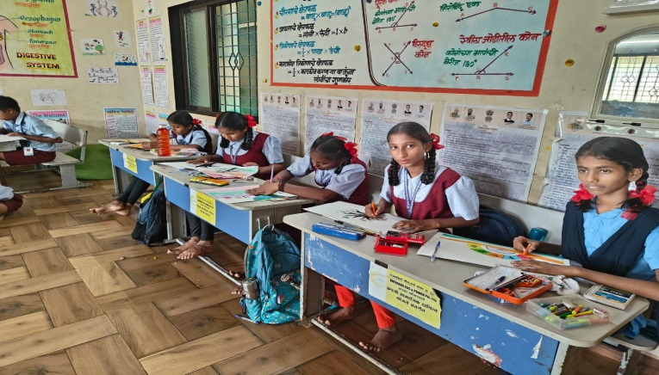
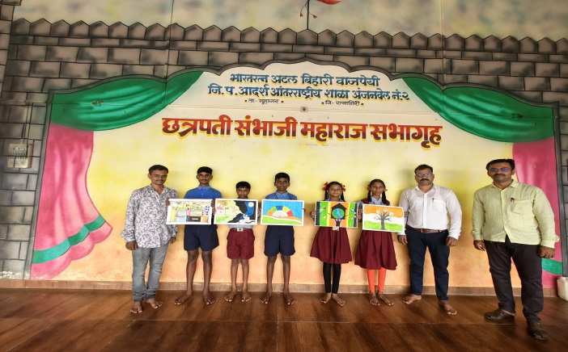 | 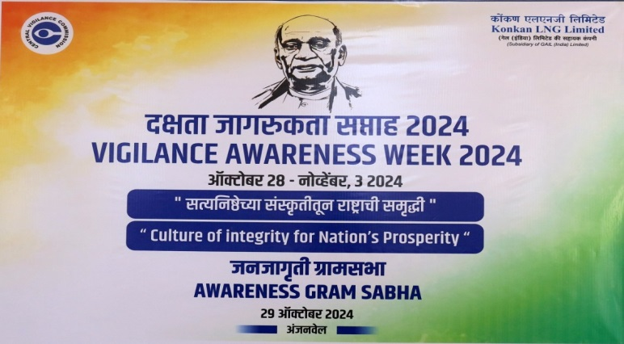
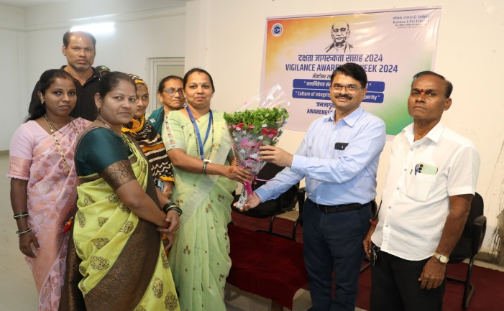 | 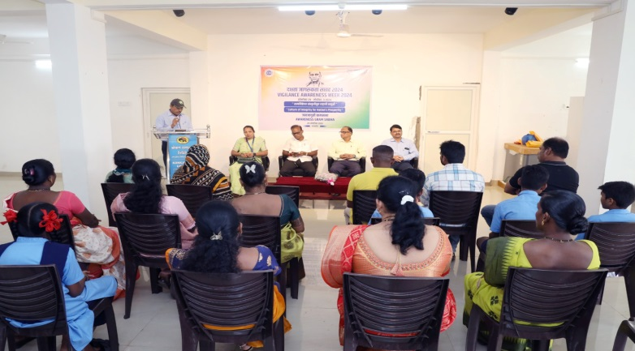
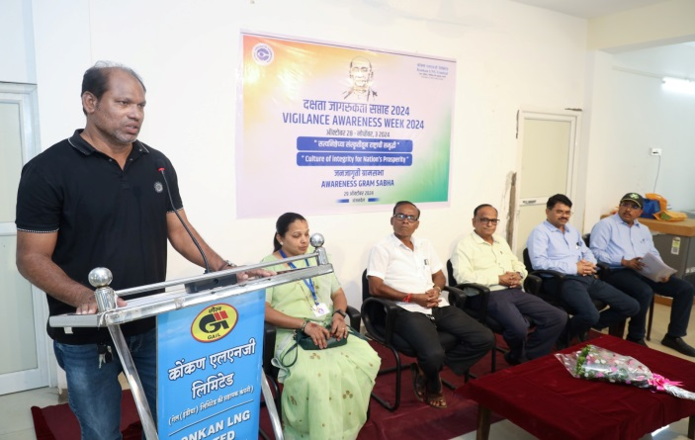 | 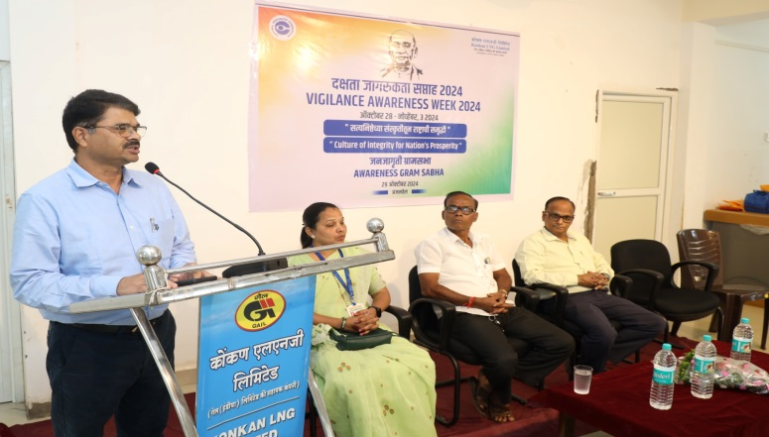
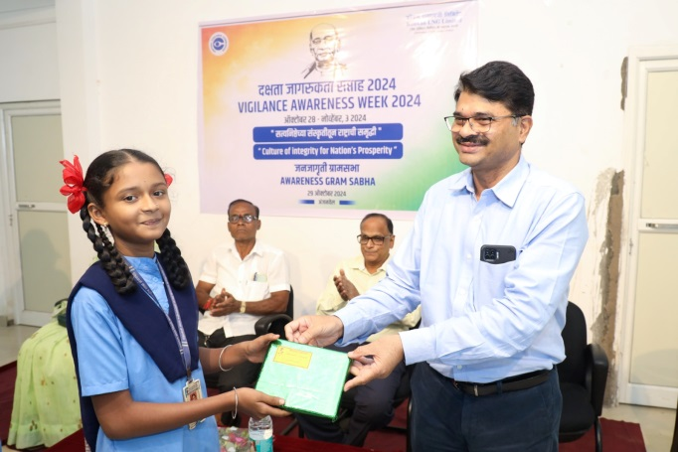 | 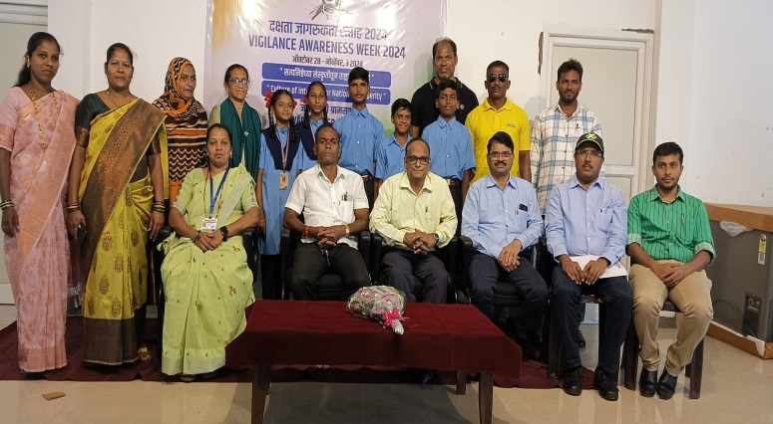
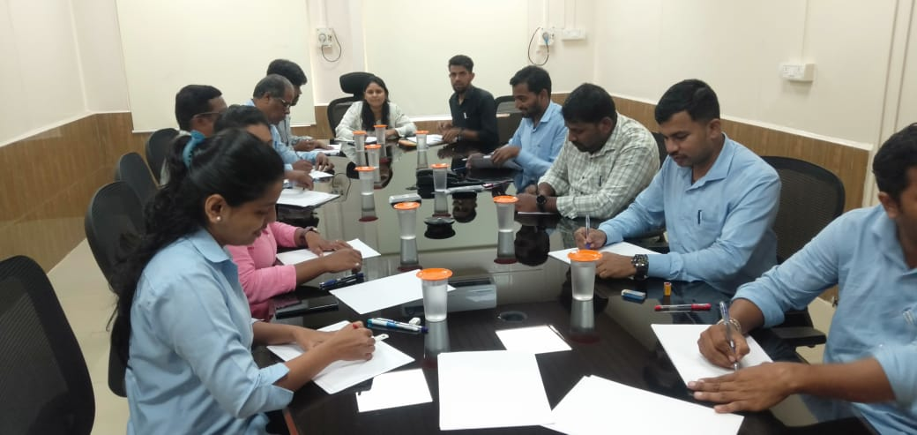 | 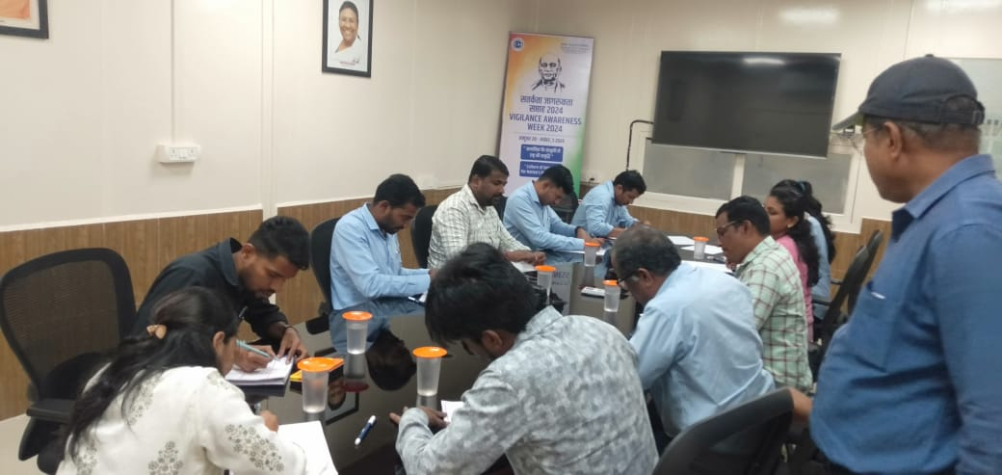
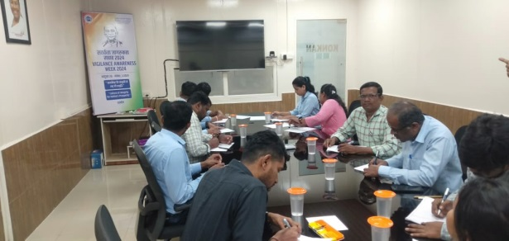 | 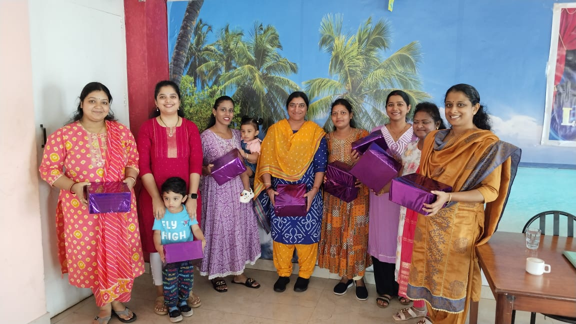
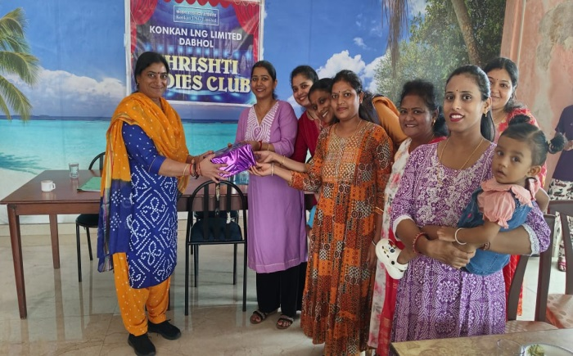 | 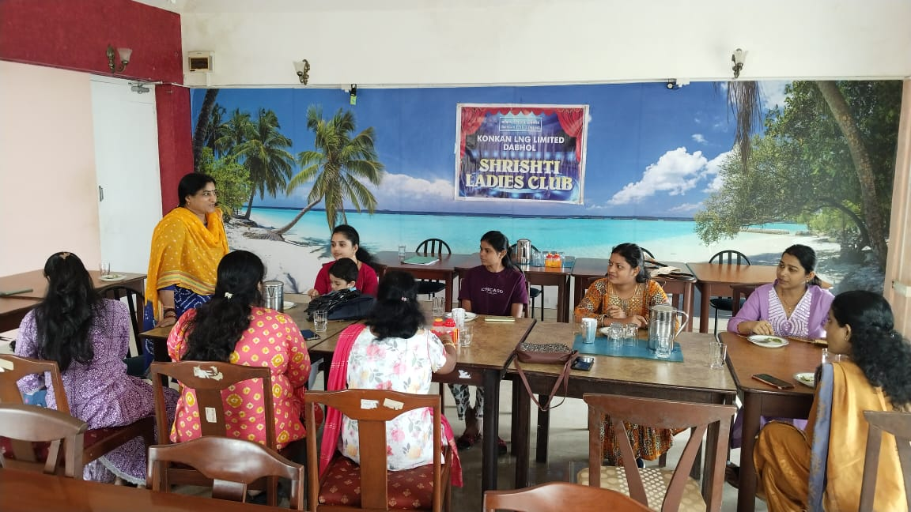
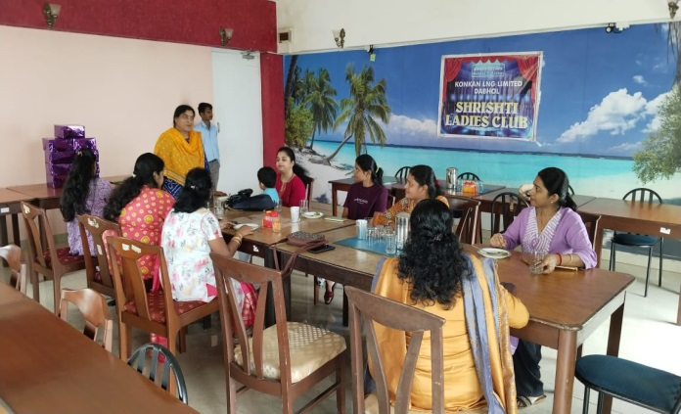 | 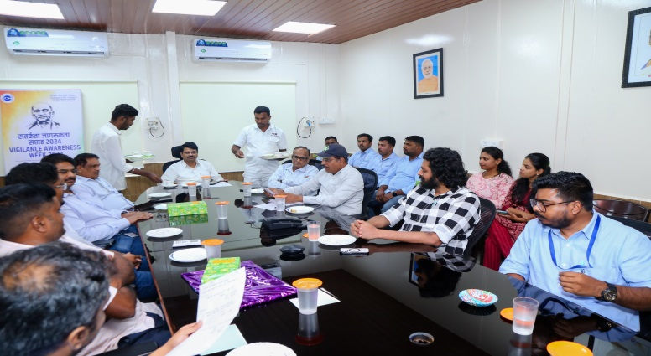
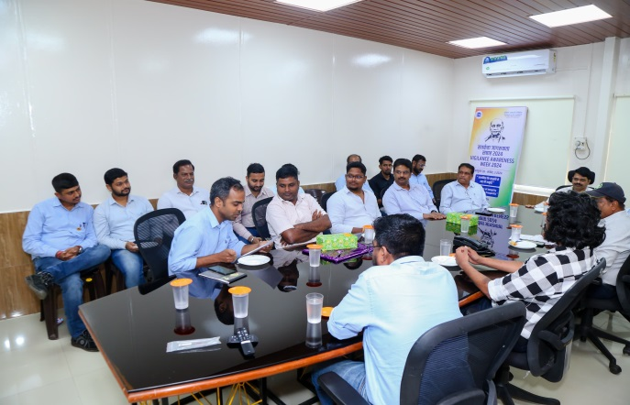 | 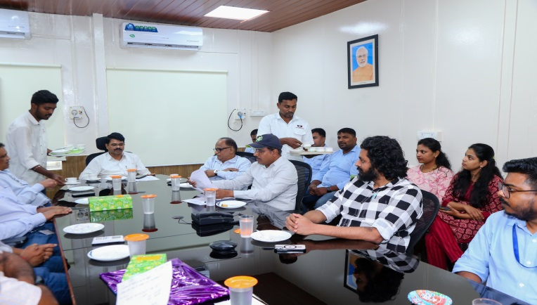
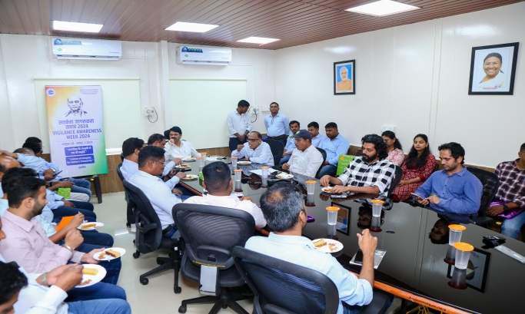 | 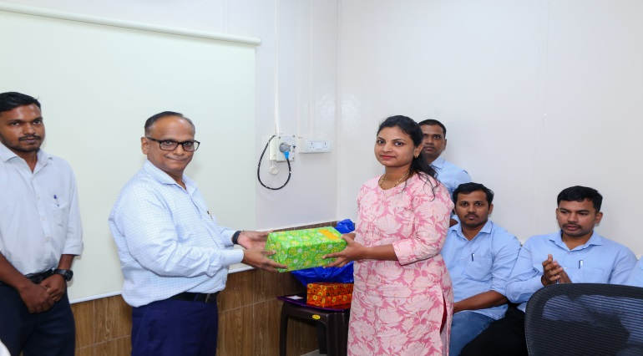
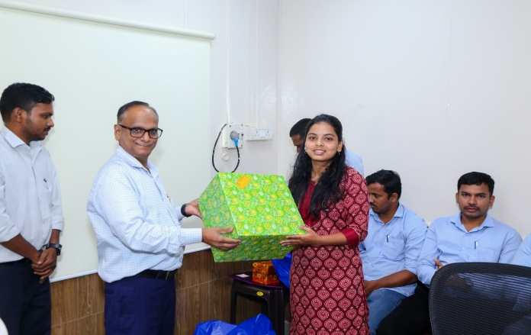 | 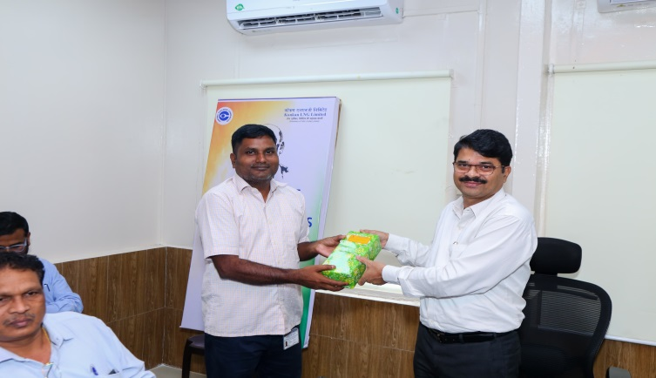
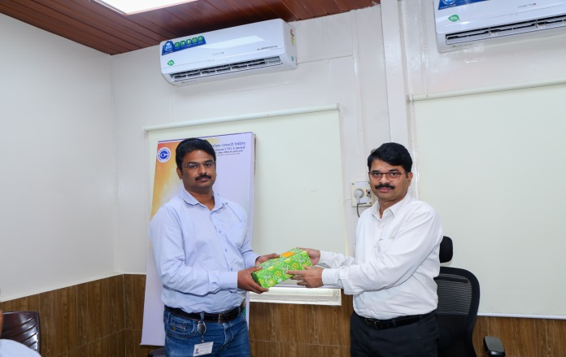 | 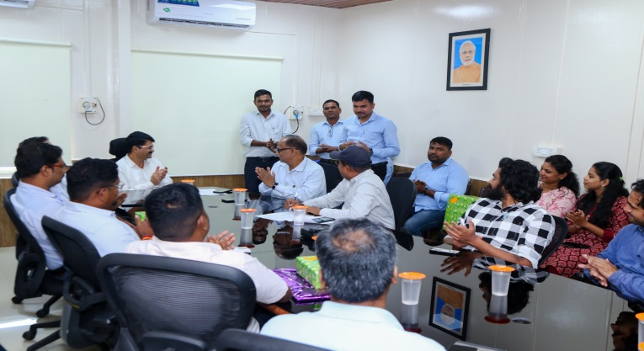

-o0o-

