Date: 07.01.2025
Brief Report on New Year 2025 Celebrations
On the occasion of New Year 2025, a Get-Together of all the Employees and their family members was organized on 05.01.2025 at a Ferry boat, Dhopave.
Sh. D B Thakur, CFO, Sh. Sanjay Gondane, GM (O&M), HoDs of various departments, employees and their family members and also the employees and their family members of GAIL Terminal were present on the occasion.
Addressing the gathering, CFO and GM (O&M) have extended warm new year wishes and health & prosperity to all the employees and their families.
Various programs were organized during the gathering in which employees, children and their family members actively participated.
The program ended with the sumptuous lunch to all the participants.

Some of the photographs taken during the program:
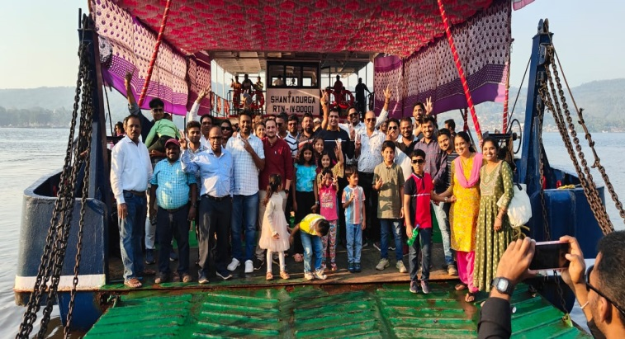 | 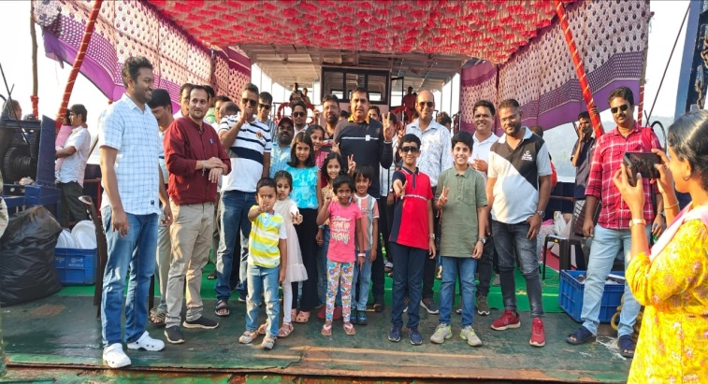
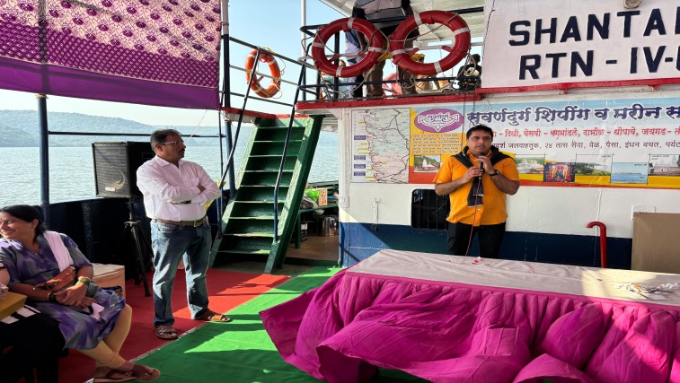 | 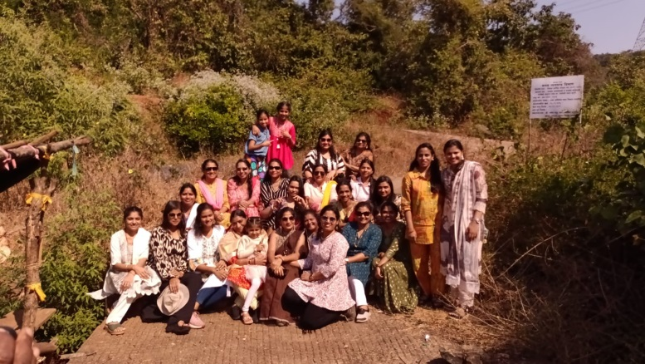
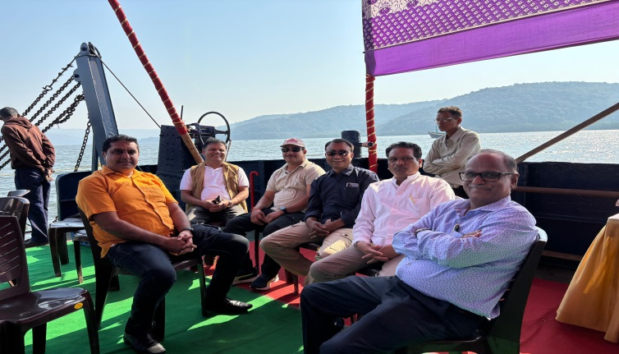 | 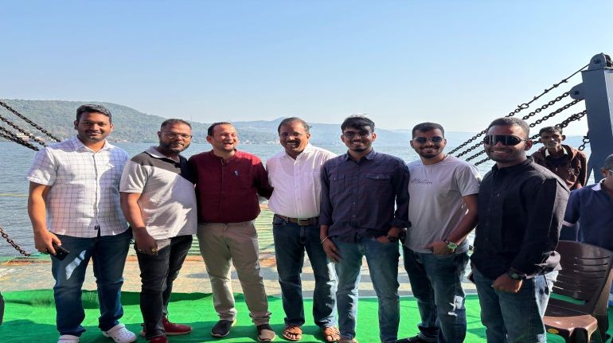
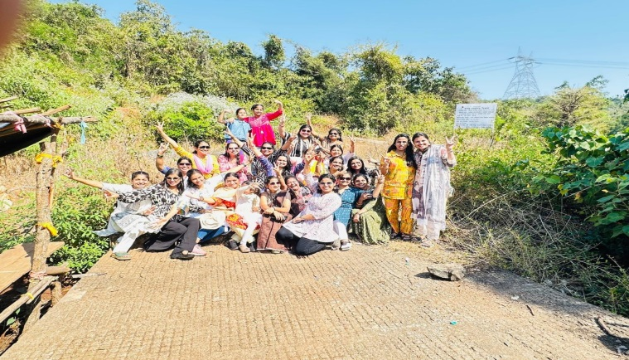 | 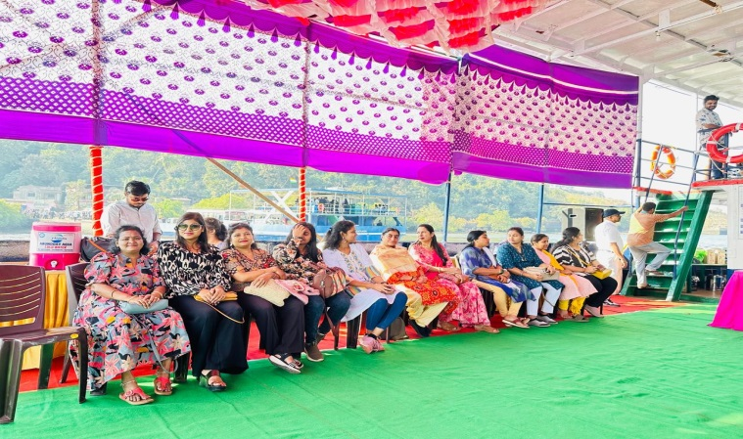

-o0o-

