Celebration of 76th Republic Day
January 26, 2025: KLL celebrated the 76th Republic Day with much fervor and patriotism. Sh. Tony Mathew, CGM/CEO-KLL & Chief Guest on the occasion, Sh. D B Thakur, CFO, Sh. M I Haque, GM (O&M-Operations), Sh. S G Gondane, GM (Civil & Marine), all HoDs, employees and their family members were present on the occasion.
Addressing the gathering, Sh. Tony Mathew extended warm wishes to all on the occasion of Republic Day, which is also celebrated as the ‘Poorna Swaraj’ with the adoption of written Constitution. He also stressed upon the addressing of contemporary issues viz. definition of equality, humanity, environmental fundamentality etc.
He appreciated the team work contribution developed in KLL, which is also acknowledged by the GAIL management and specially appreciated the Operations Dept. and all the teams involved for running the plant uninterruptedly.
He also mentioned the importance of hard work for achieving a goal with primary condition as honesty, uprightness etc., which leads to the success of an individual.
The platoon of Maharashtra Security Force (MSF) has given the Guard-of-Honor to the Chief Guest and Parade on the occasion, which has been appreciated by all.
The program ended with the serving of Tea & Snacks to all the participants.
Some snapshots of the program:
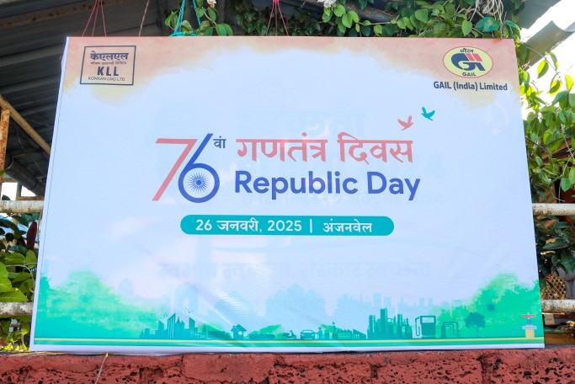 | 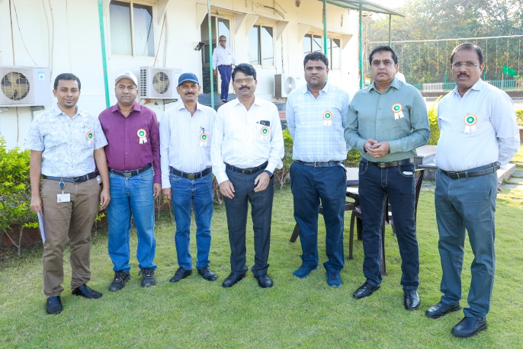
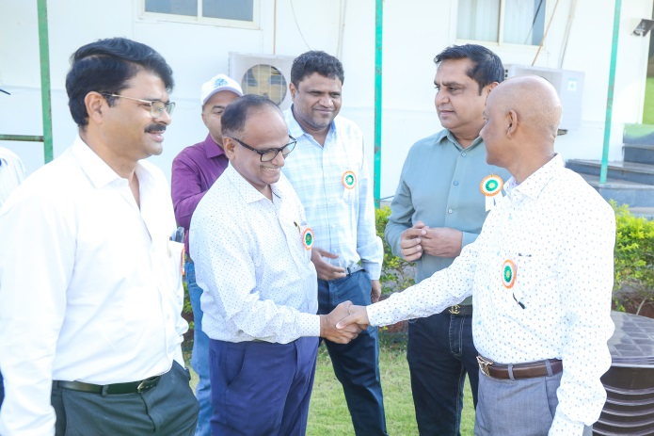 | 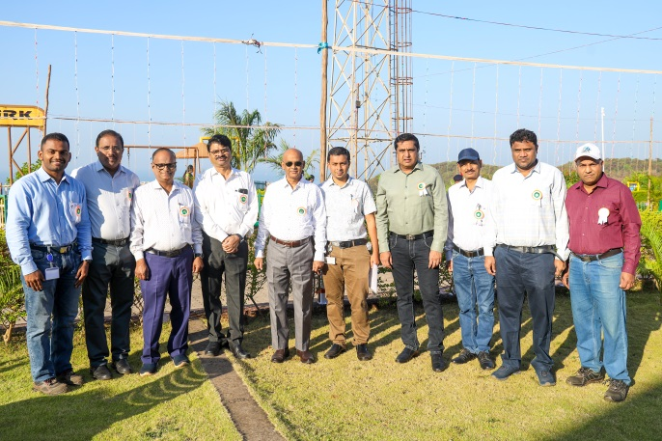
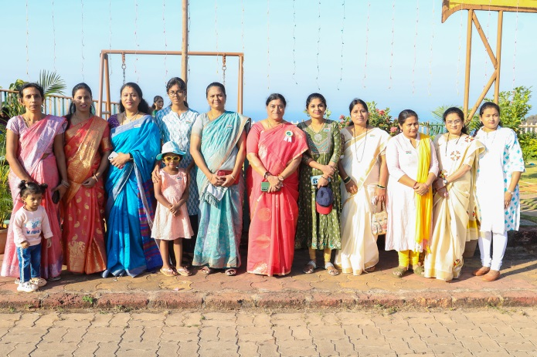 | 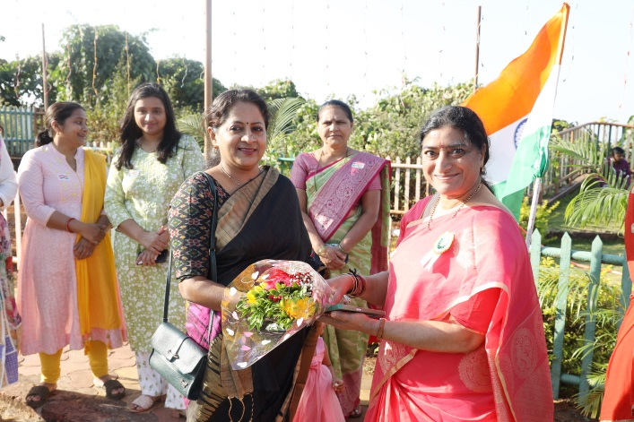
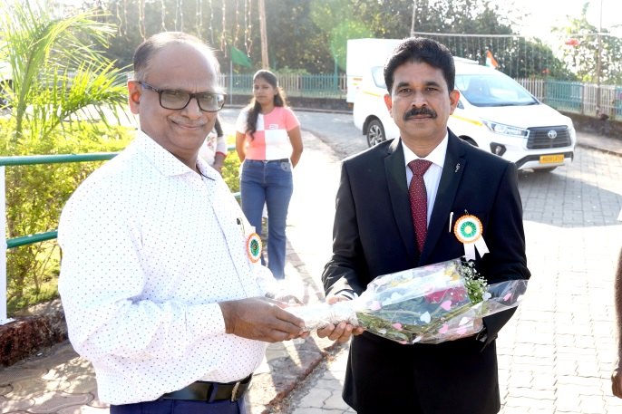 | 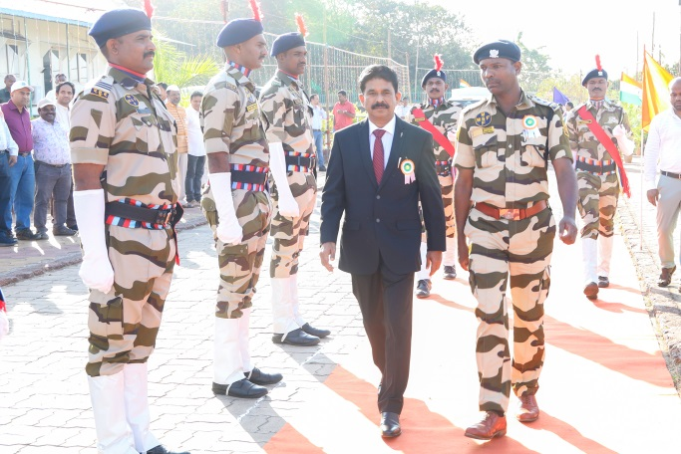
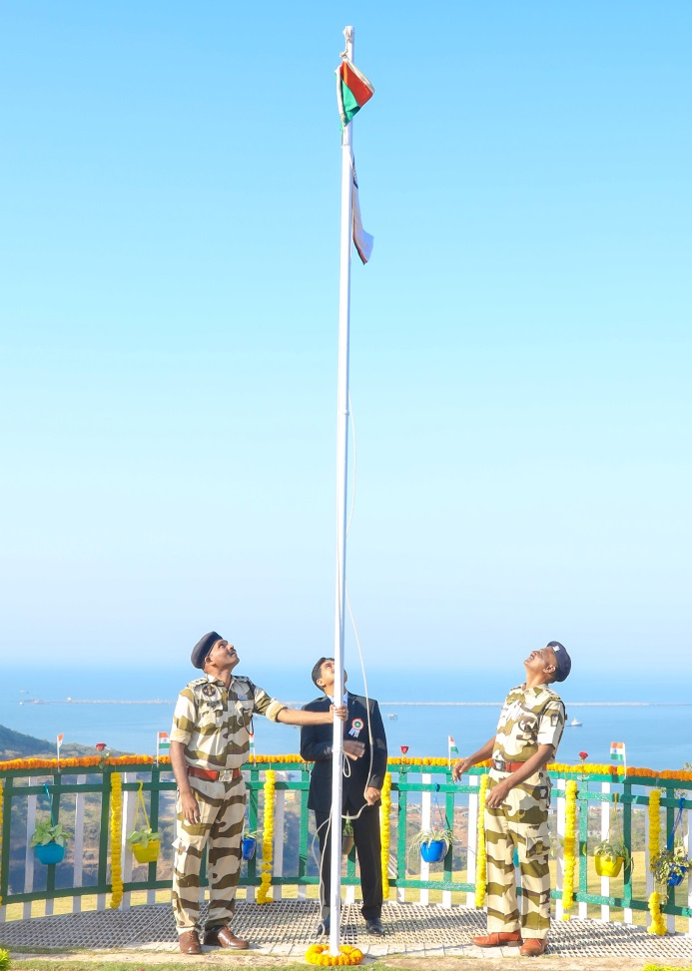 | 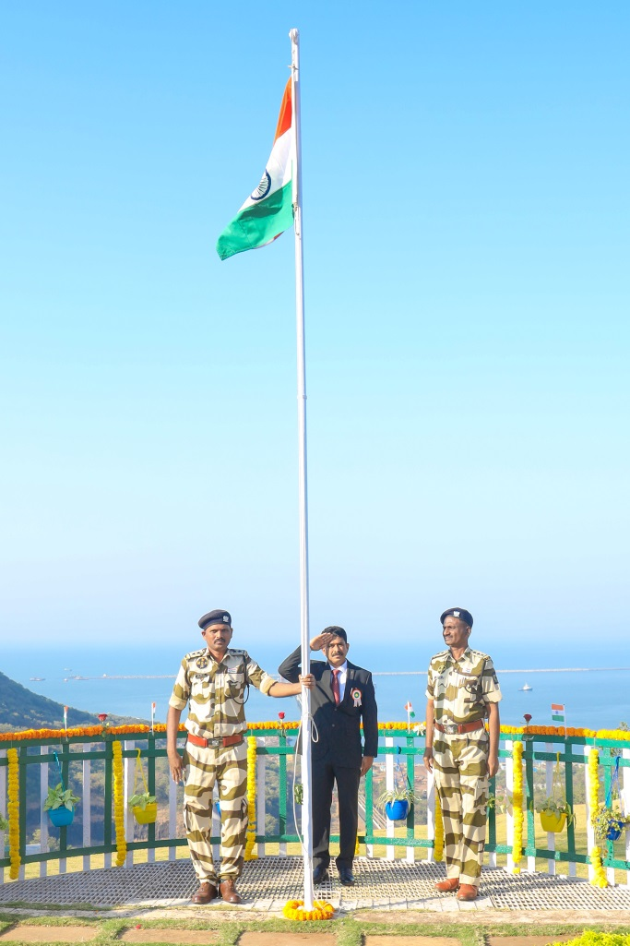
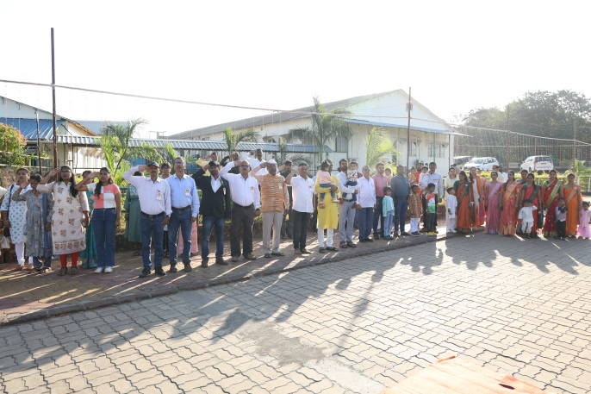  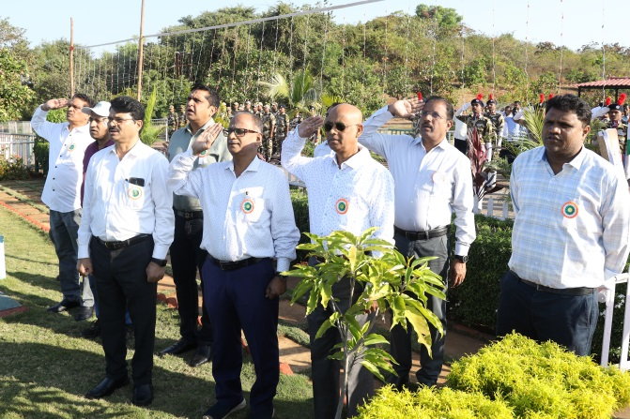 | 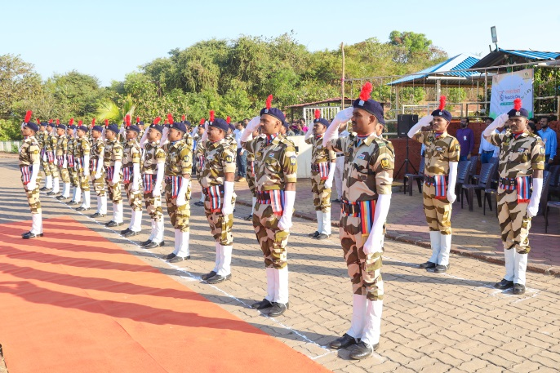
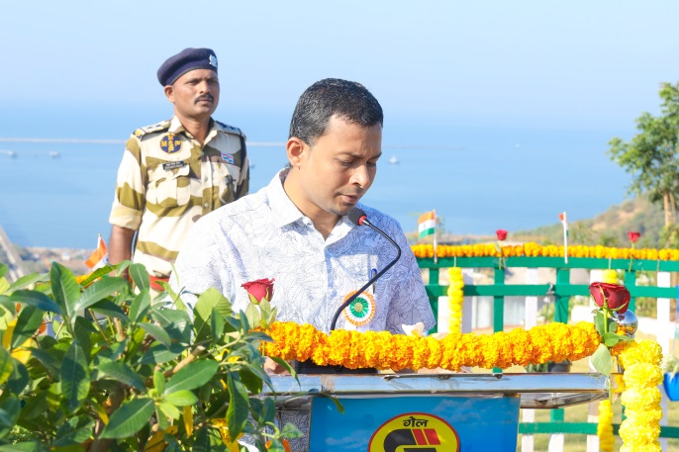 | 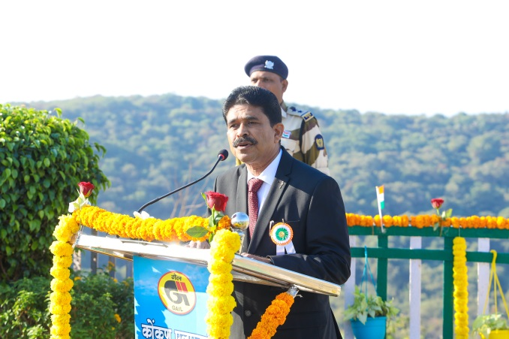
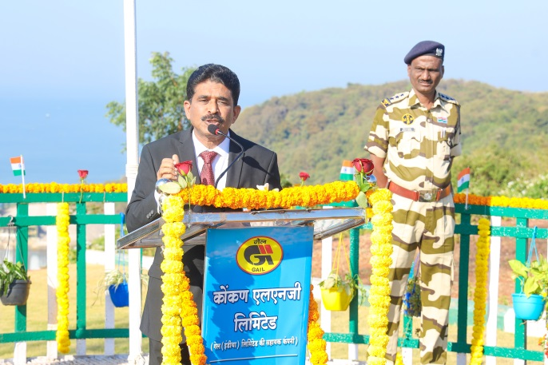 | 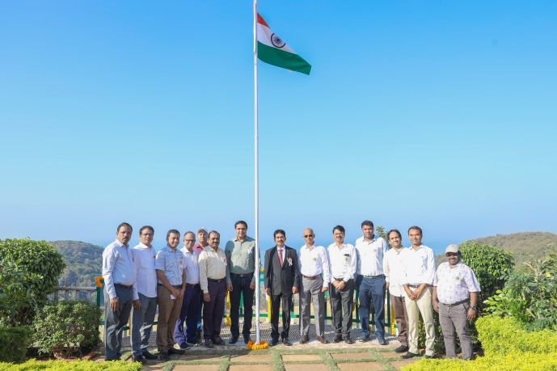
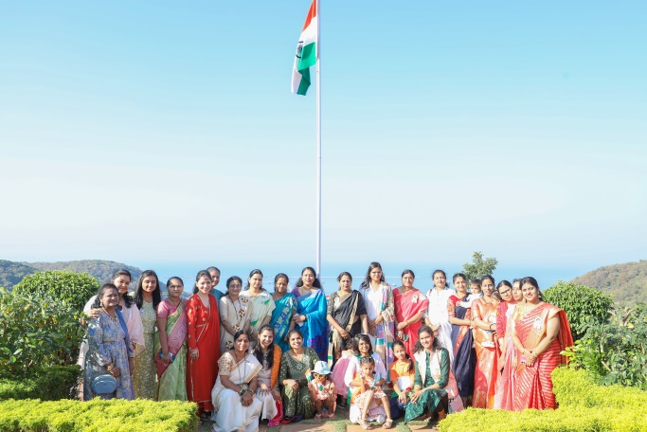 | 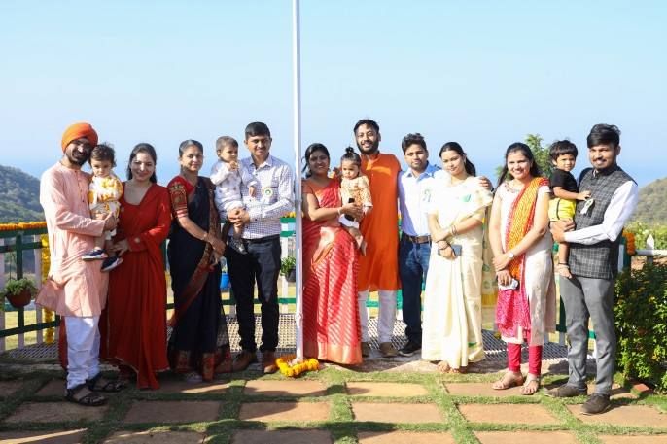
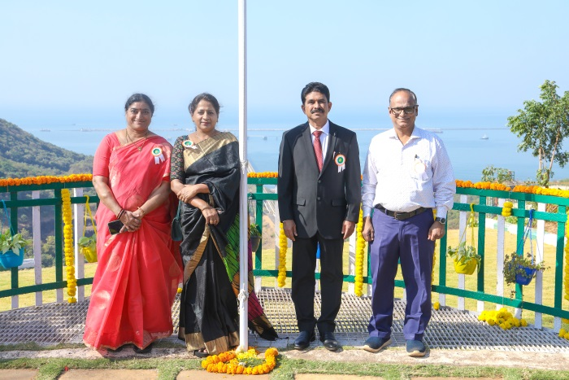 | 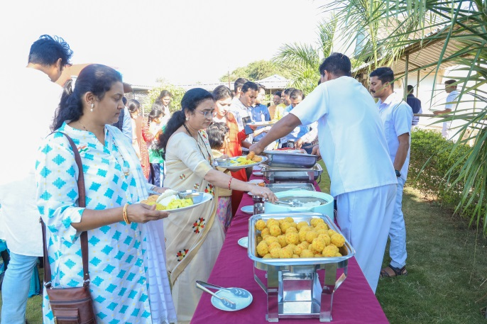
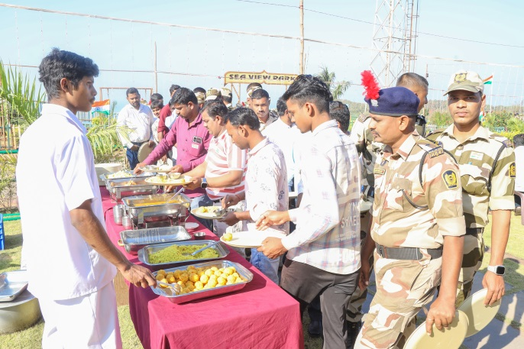 | 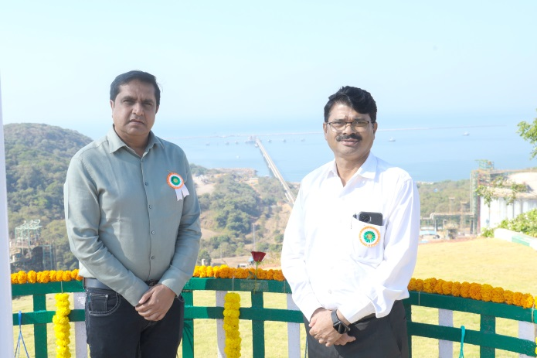

-o0o-

