Visit of Sh. Deepak Gupta, Director (Projects), GAIL
to KLL from 23rd to 24th January, 2025

January 27, 2025: Sh. Deepak Gupta, Director (Projects), GAIL have visited KLL-Dabhol from 23rd to 24th January’25 for review of Balance works of Breakwater Project and KLL-O&M Activities.
Sh. Deepak Gupta has been warmly welcomed by Sh. M I Haque, GM (O&M-Operations), Sh. Sanjay G Gondane, GM (O&M-Marine & Civil) and Sh. S P Reddy, DGM (HR).
On 23.01.2025, Director (Projects) along with the executives of KLL, EIL and L&T have visited the Breakwater Project site. Director (Projects) have complemented EIL Team for achieving the SIX Million Man-Hours of work without any Lost Time Accident as on 20.01.2025 in construction of Balance Works of Break Water Project and presented a Certificate commemorating the achievement. Director (Projects) have also visited the KLL Jetty and LNG Cargo Ship ‘LNGC SERI BALHAF’ having berthing on the day and interacted with the employees. The Review Meeting of the Breakwater project was organized in the KLL Conf. Hall, which was attended by executives of GAIL/KLL, EIL and L&T etc. and briefed the current status of the project and hurdles being faced by the project. Keeping in view the Project Target Date, Director (Projects) have given instructions to all concerned teams to achieve the project completion as per the deadlines given.
In the evening, an Interactive Session of Director (Projects) with Employees has been arranged at Hotel Woods, Guhagar, wherein all the Employees were participated. Welcoming the Director (Projects), Sh. Tony Mathew, CEO have apprised the various welfare activities and initiatives taken up by KLL in the recent past for the benefit of employees posted at Dabhol being a Hard Location. Some of them are shifting of Employees’ Personal Files from GAIL-Mumbai to KLL-Dabhol site with the consent of Corporate HR for quick processing of claims and advances by site HR, Welfare fund of Dabhol employees made available to the site & Picnic arranged for employees & family members for the first time, Doctors are engaged on hiring basis to visit plant on fixed hours every day of the week etc. CEO also informed about the land applied for construction of KLL Township, which is actively considering by MIDC for allotment soon. CEO also informed about the Security Services Contract change from CISF to MSF, which has reduced huge financial burden on KLL. Director (Projects) have praised the efforts and changes brought by KLL with active initiation of Sh. Tony Mathew, CEO and complemented all the employees for handling cargo unloading smoothly and advised to be positive, keep learning and reiterated that the experience KLL employees getting at Dabhol is a unique one and very few people in GAIL have had this kind of work experience. He described the KLL team as an agile and competent one. Director (Projects) have also urged KLL to expedite the execution of Ambient Air Heating System besides other projects to achieve 100% capacity utilization of the plant.
On 24.01.2025, Director (Projects) took part in the 100 Nos Sapling plantation program in Emergency Control Centre (ECC) Building premises. He also visited the ECC building which is having alternative control panel of the plant. The executives of Instrumentation Dept. have explained to the Director (Projects), the operating system of the ECC.
Director (Projects) have also visited Truck Loading Facility (TLF), which started operations recently and KLL Plant Process Area and reviewed the O&M activities of KLL. Also visited GAIL Terminal adjacent to the KLL Plant and interacted with the Employees.
The visit was ended with the sumptuous Lunch arranged in the RGPPL Vashisti Guest House.

Director Visit (23/01/2025 to 24/01/2025)
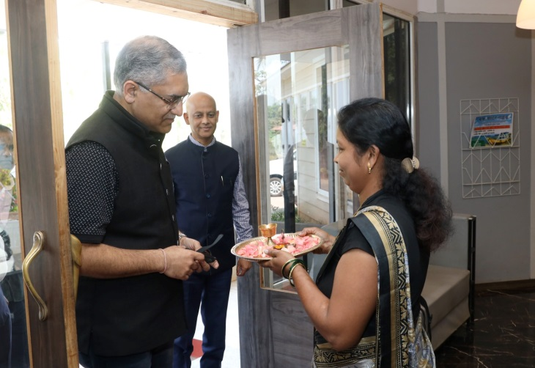 | 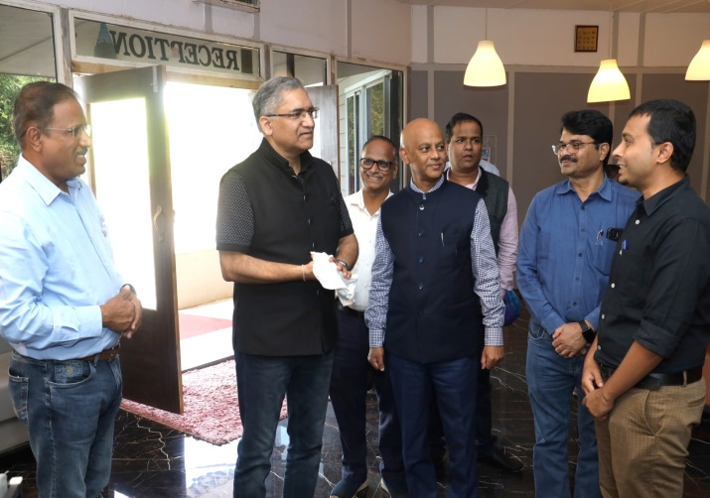
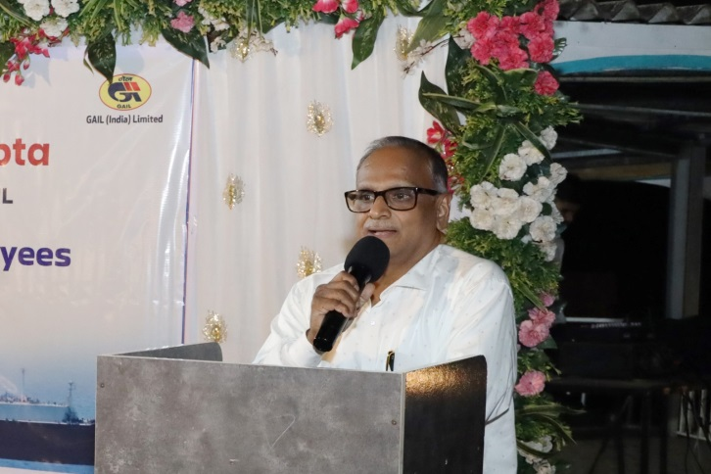 | 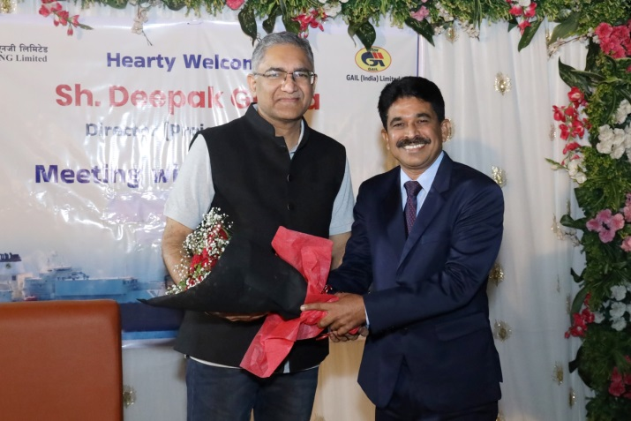
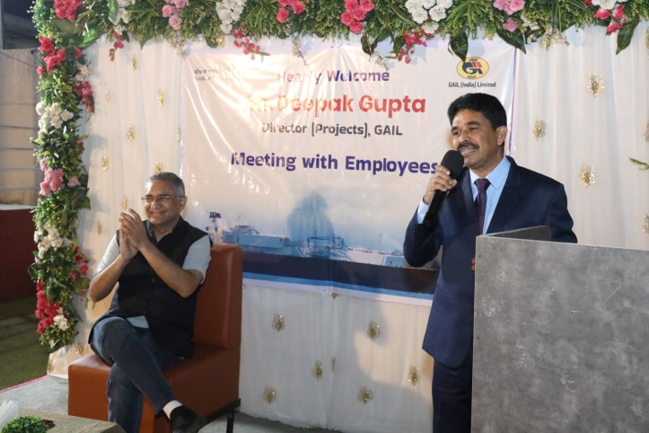 | 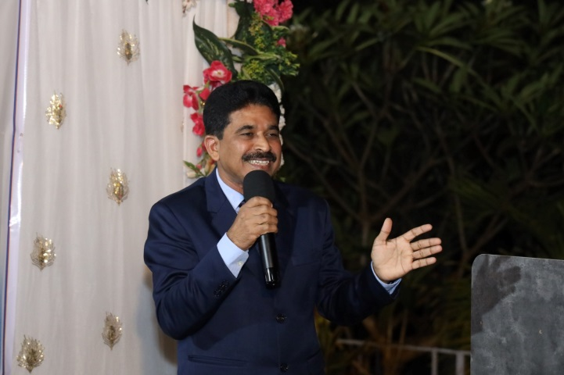
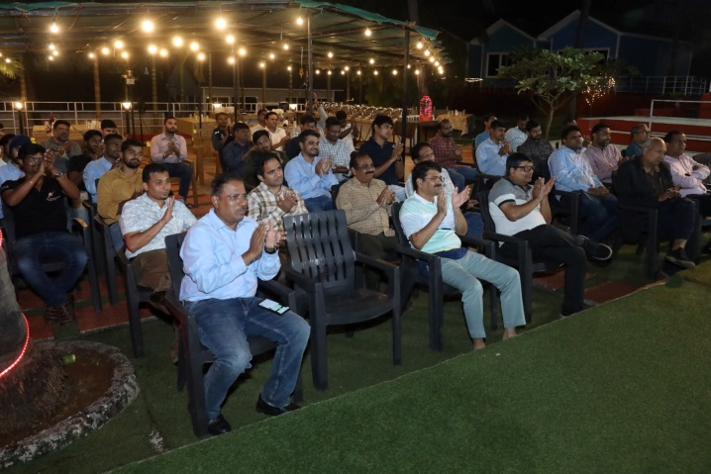 | 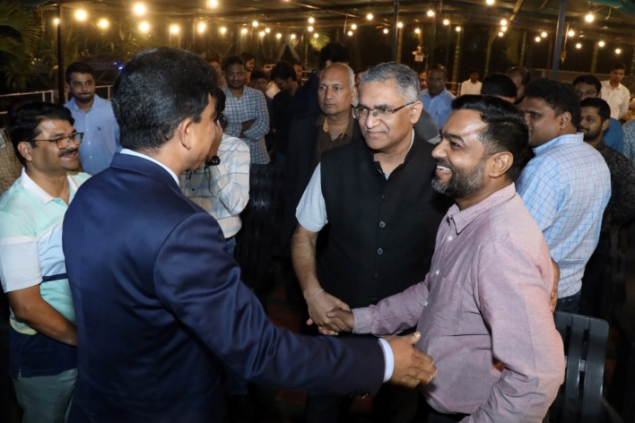
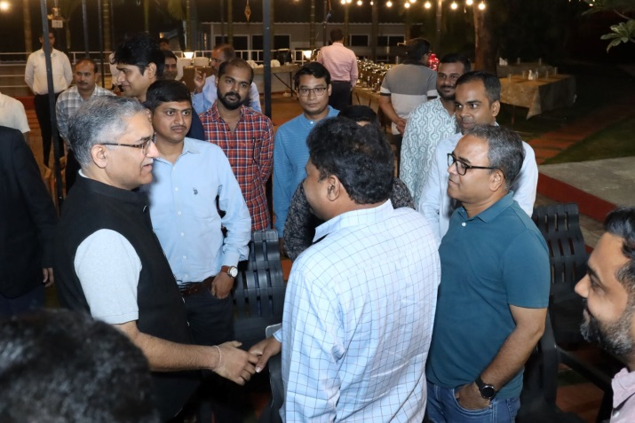 | 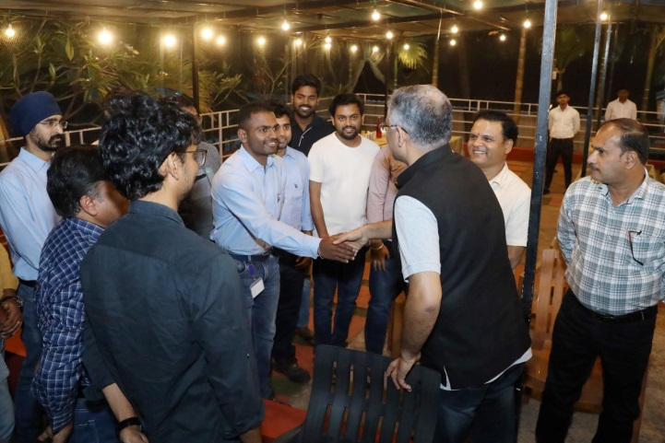
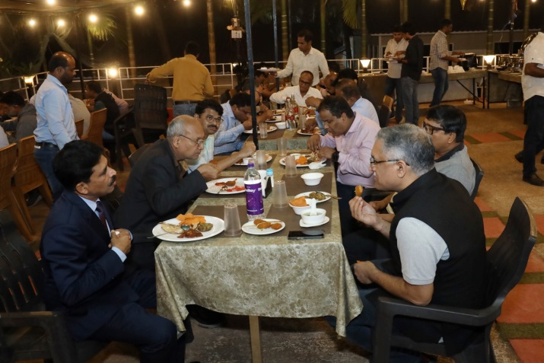 | 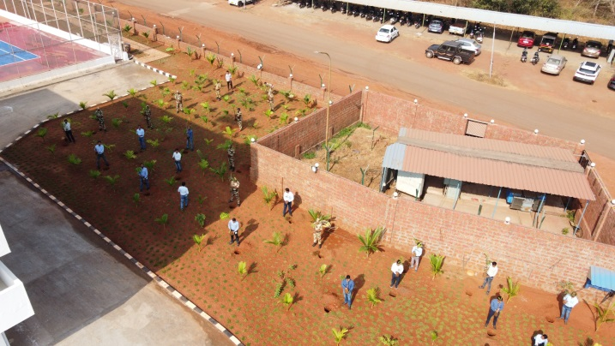
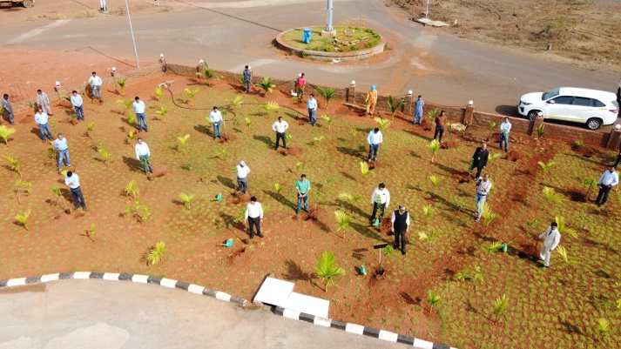 | 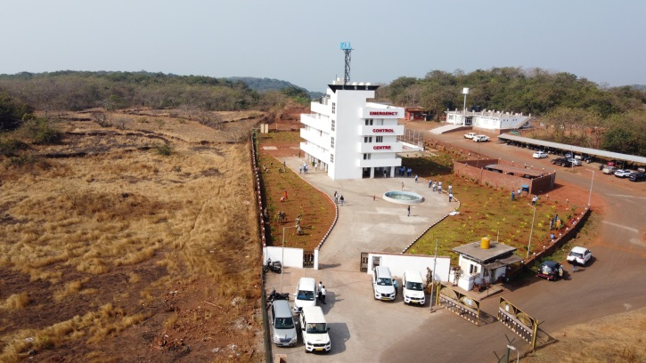
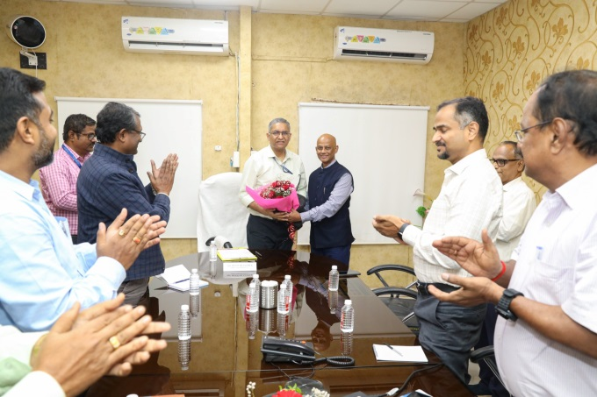 | 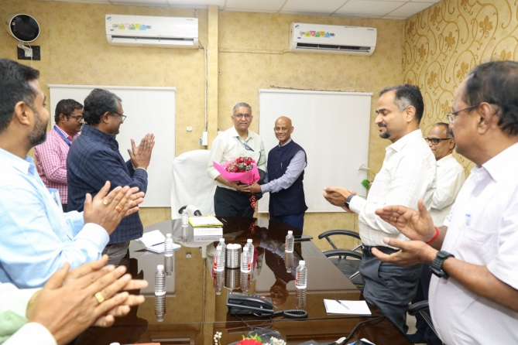
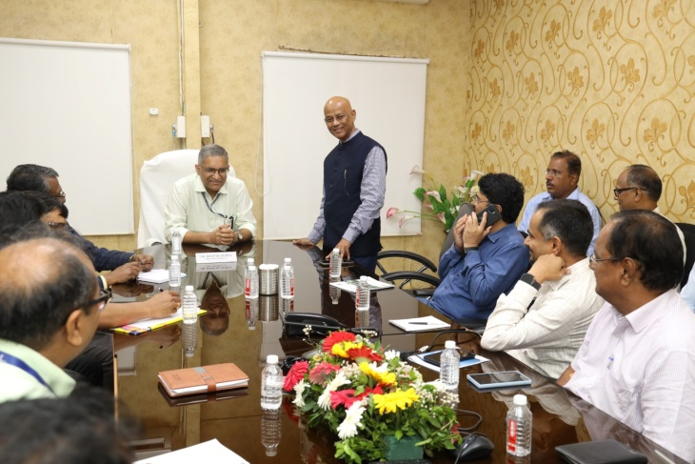 | 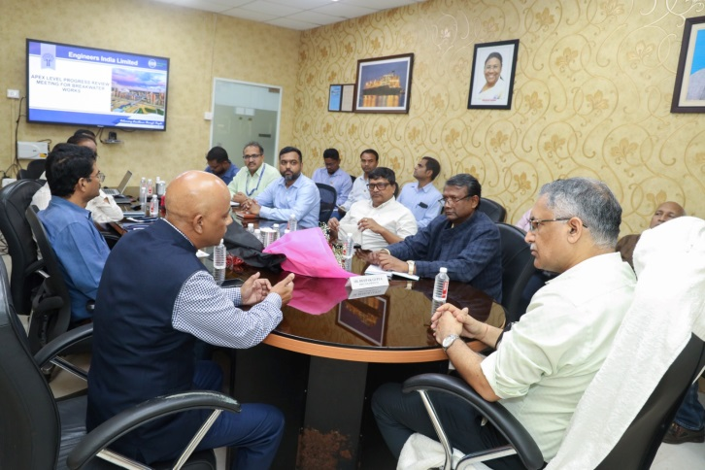
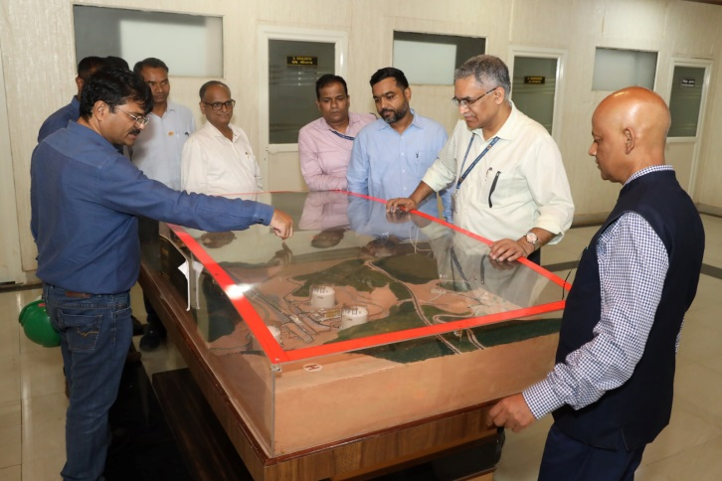 | 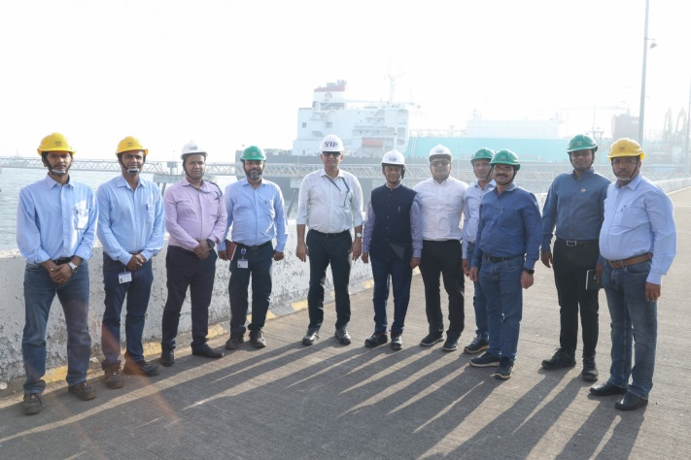
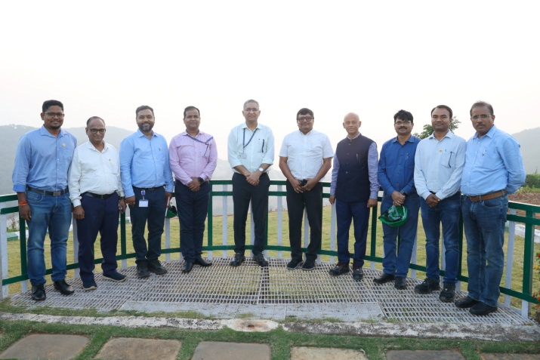 | 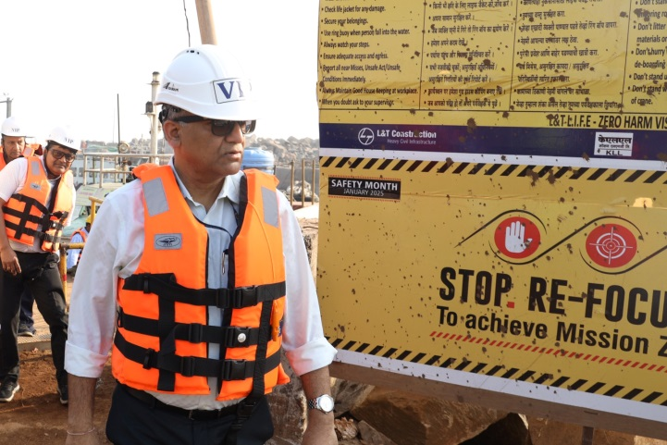
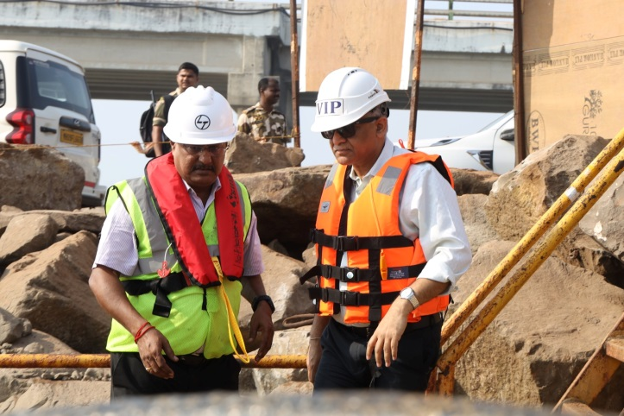 | 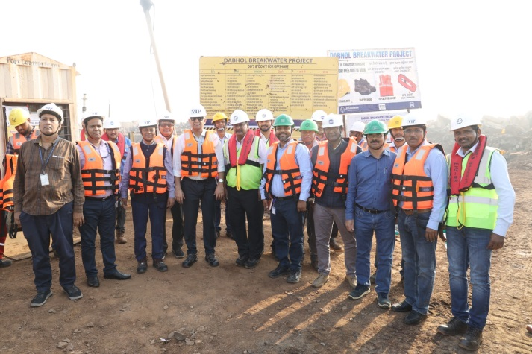
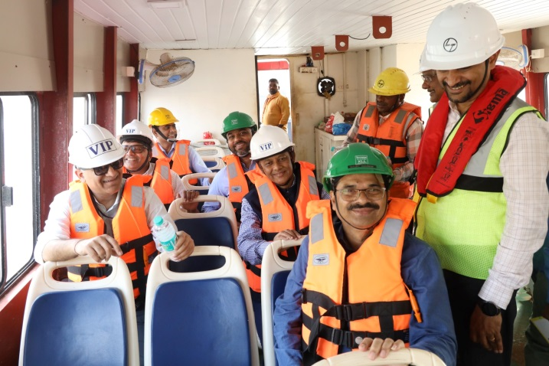 | 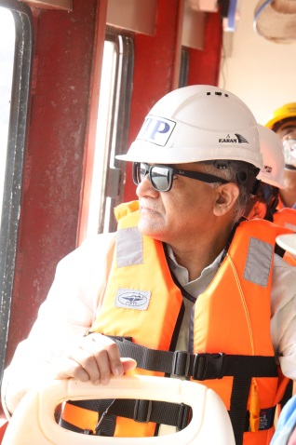
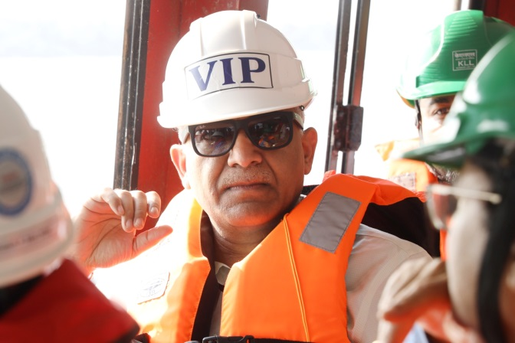 | 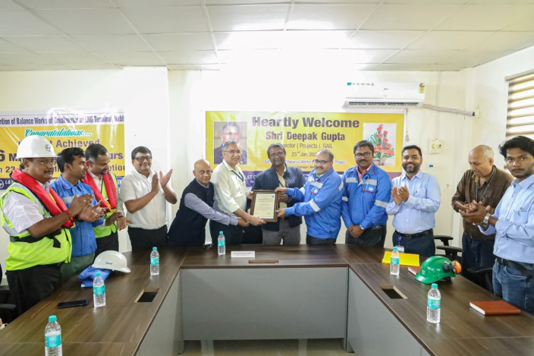
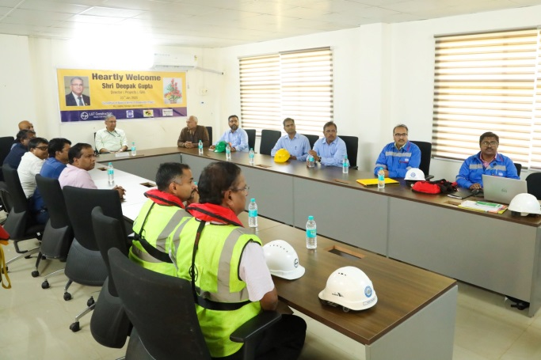 | 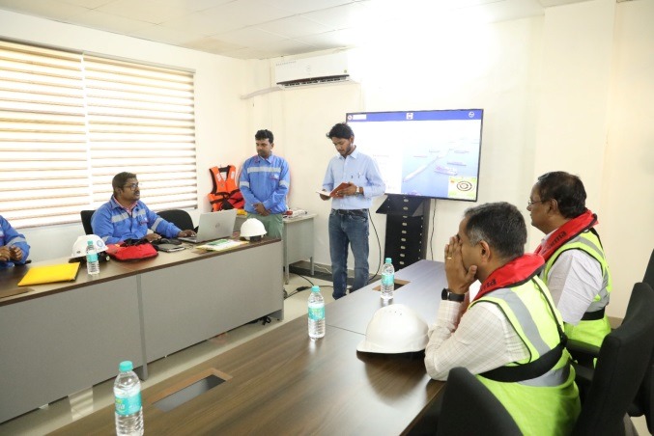
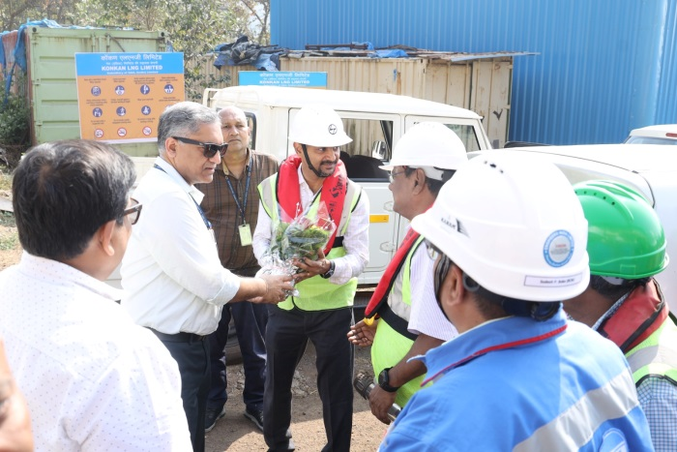 | 